Name – Parth Patil

Course – BCA

**Cloud computing AWS**

**Task 1**

For monolithic : 1 EC2 instance, deploy wordpress and MYSQL on the same instances

Step1: Login in AWS account.

Step2: Launch EC2 instance.

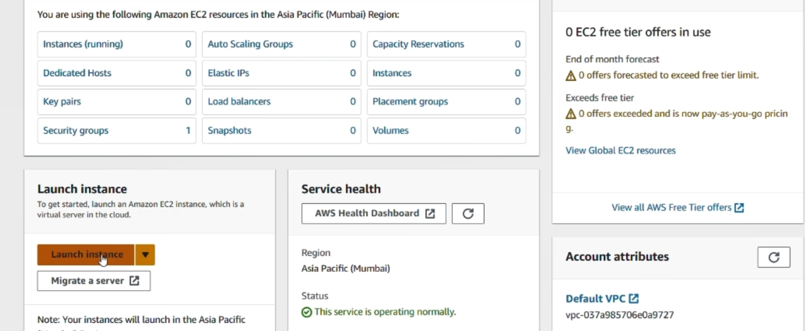

Step3: Select Ubuntu

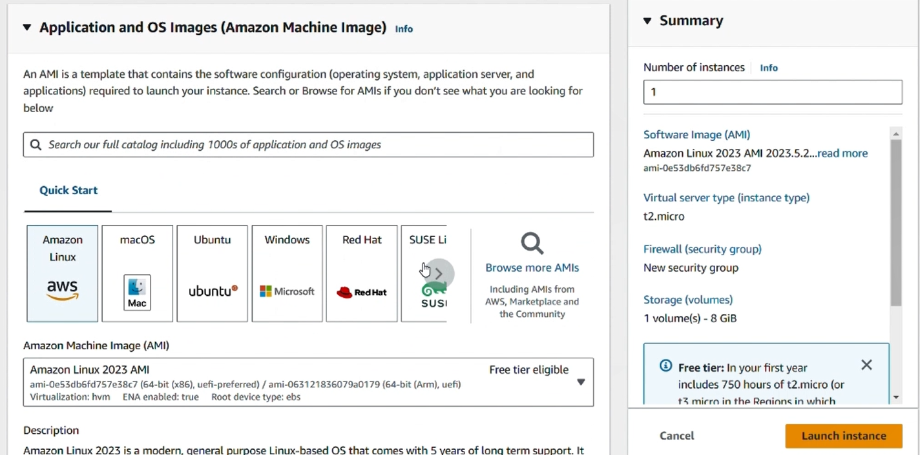

Step4: Select instance type as t2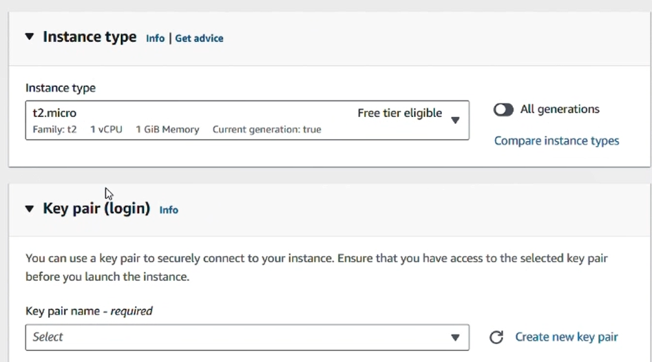

Step5: create key pair

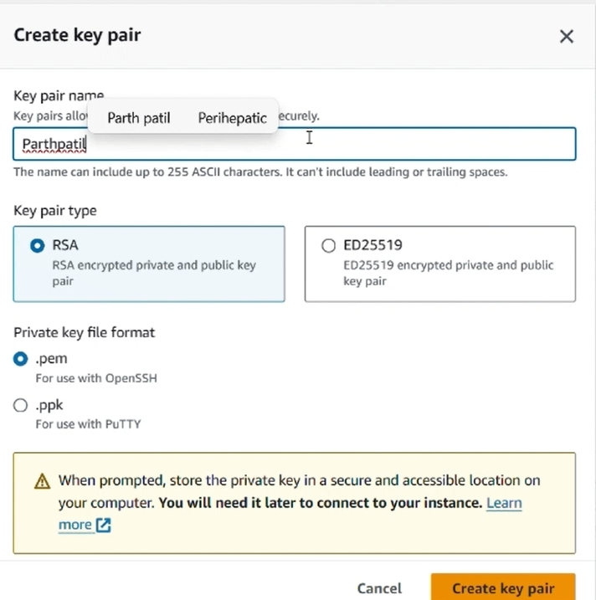

Step6: Create Security group

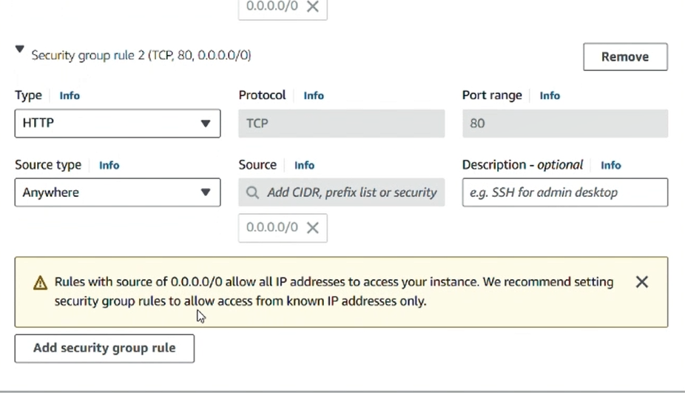

Step7: Launch instance

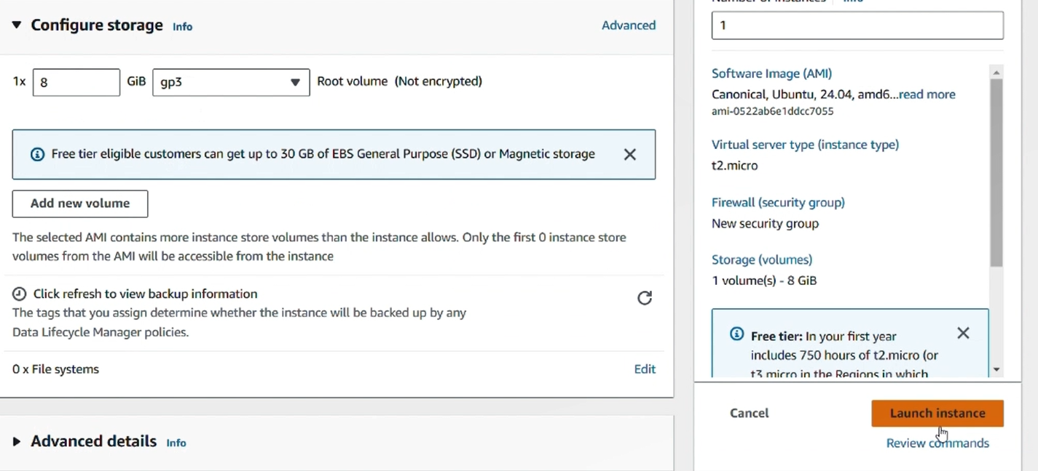

Step8: initiate mysql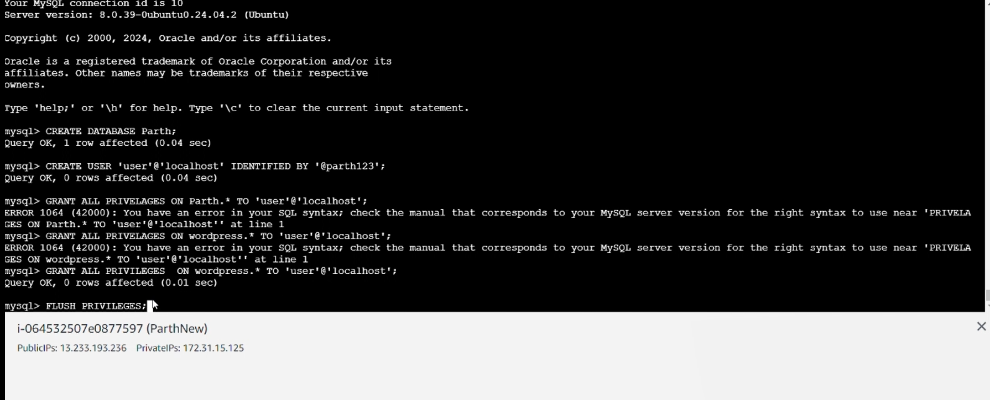

Step9: Write user name and password

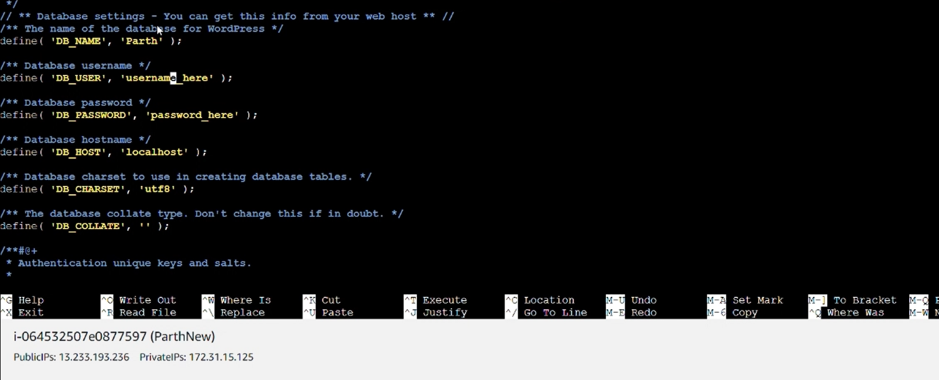

Step10: Launch wordpress site by ip address

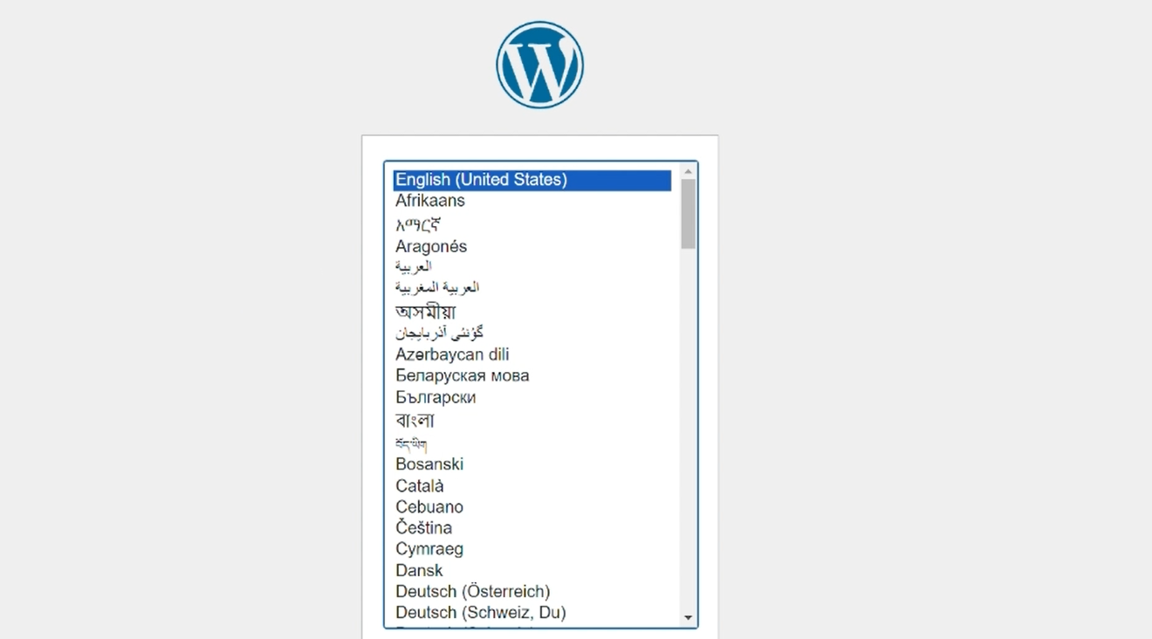

Step11: Sign in the wordpress 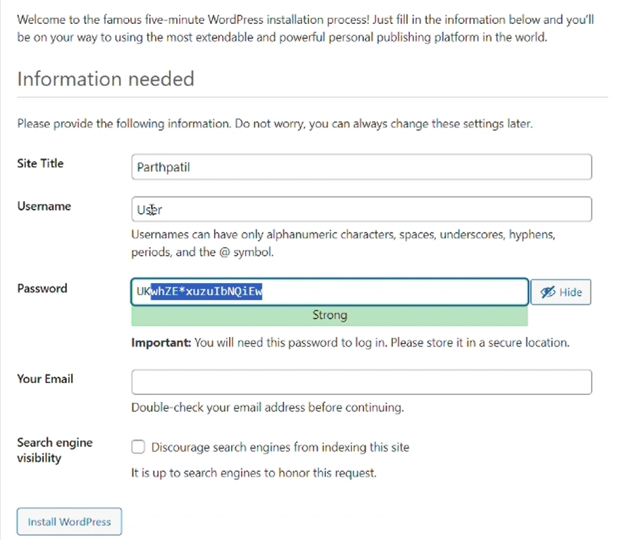

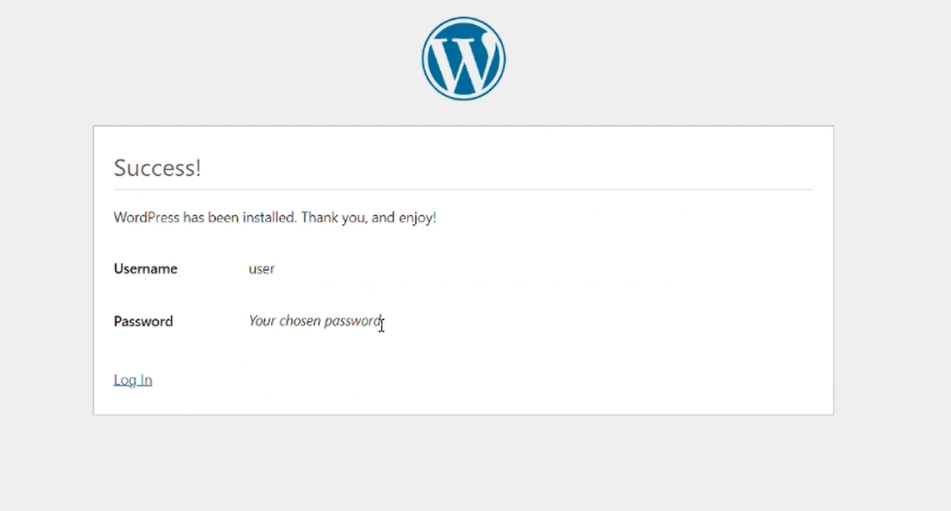

Step 12: Create sample page on wordpress

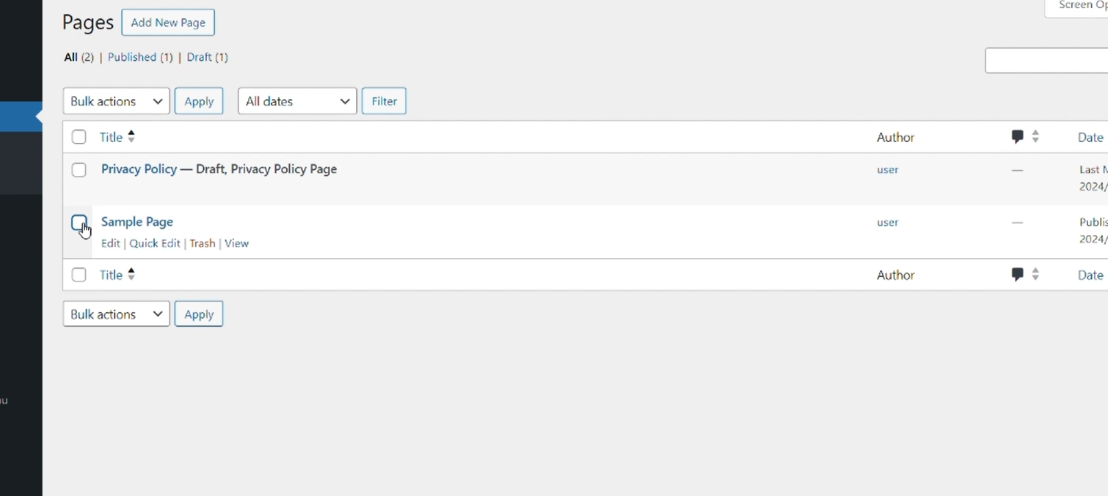

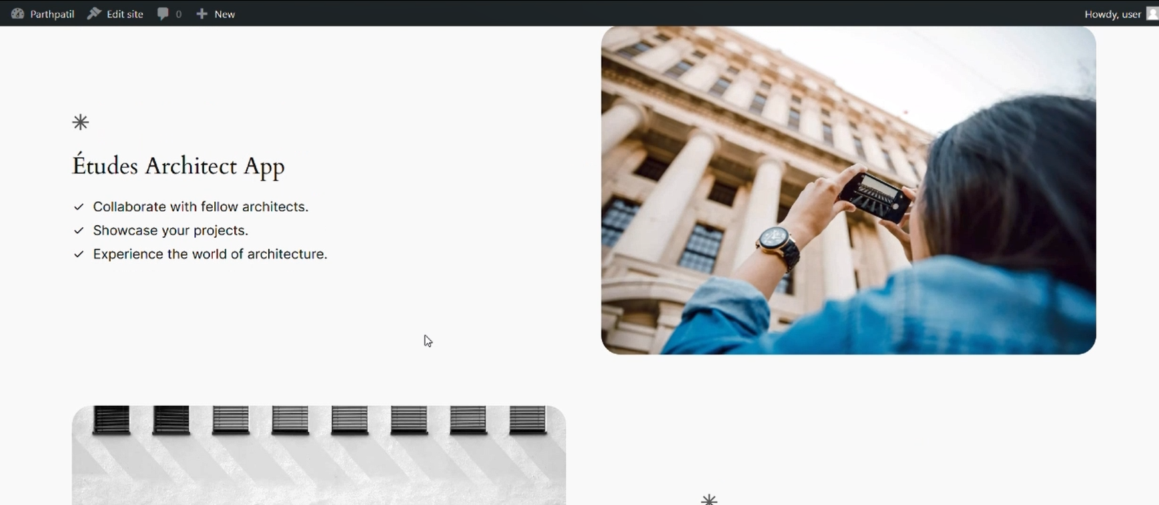

**Task 2**

For microservices : 2 EC2 instances , 1 for wordpress and 1 for MYSQL

Step1: Create 2 microservices

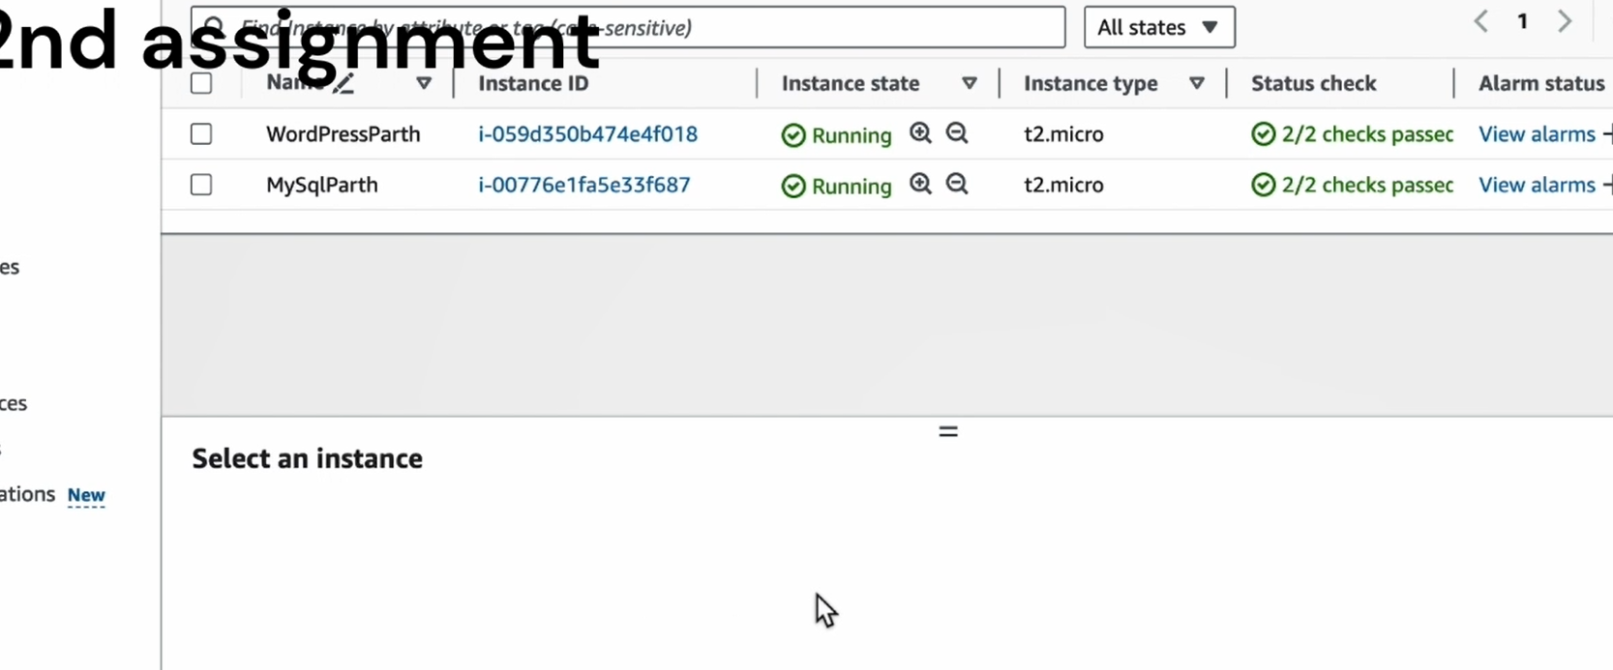

Step2: Setup security groups

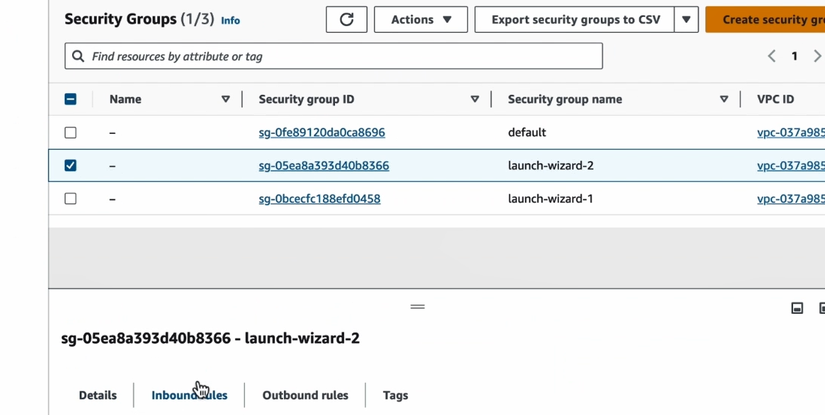

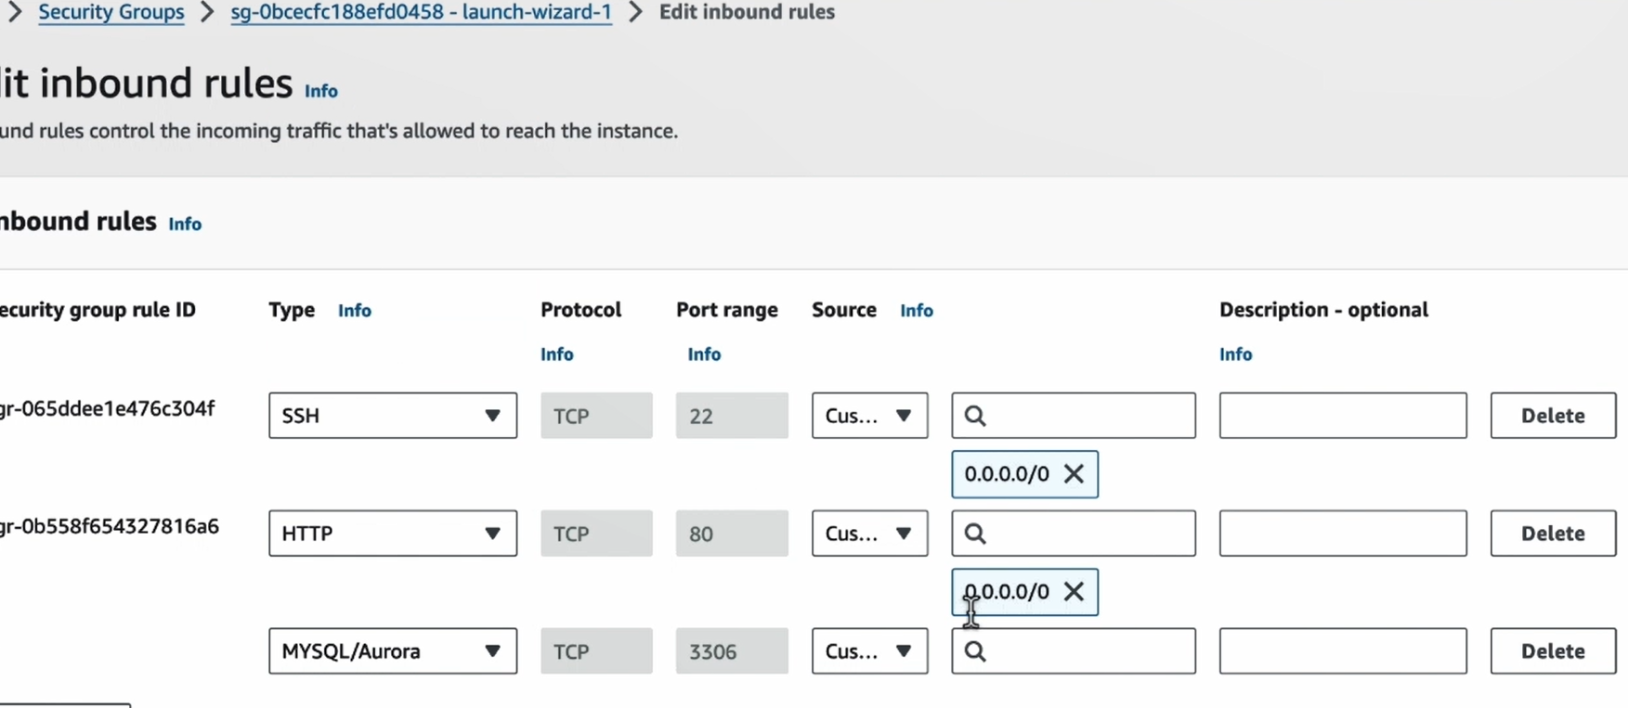

Step3: launch and install mysql

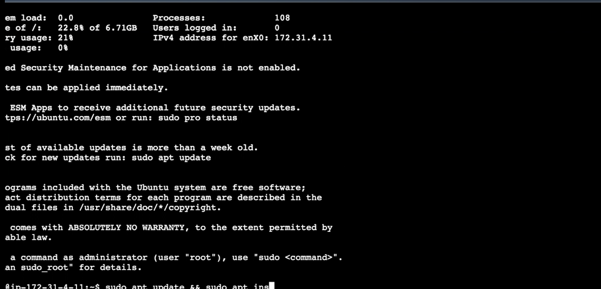

Step4: create user

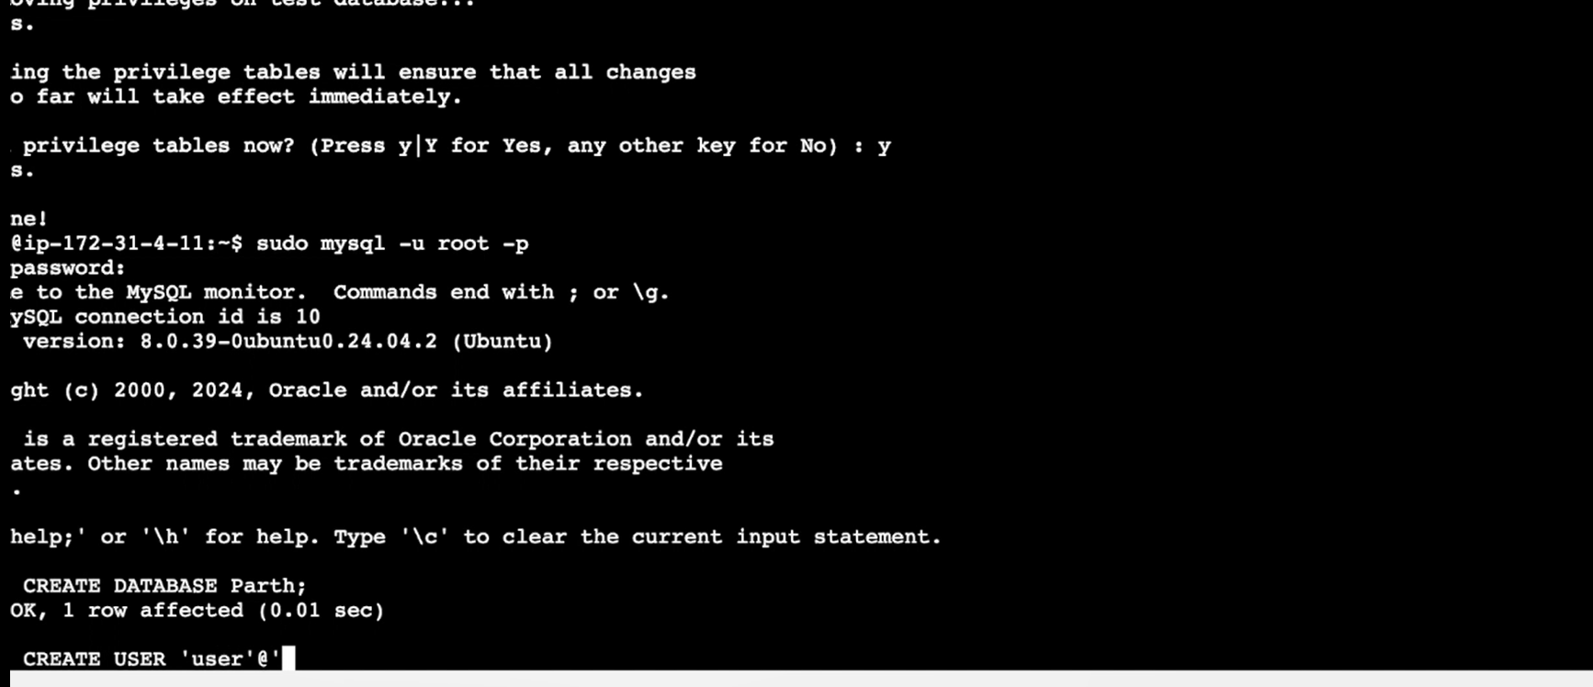

Step5: Get wordpress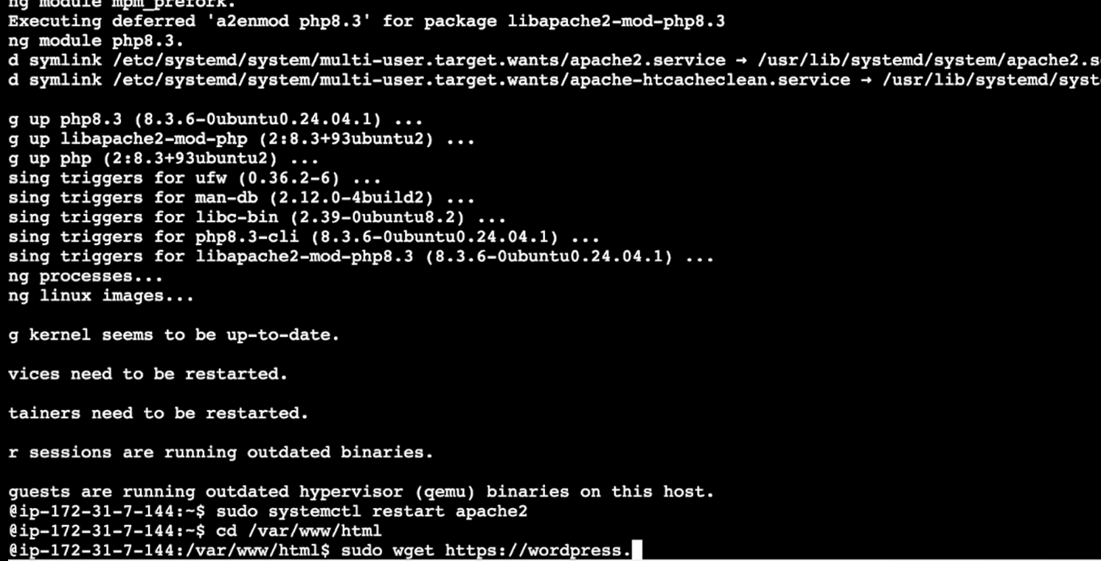

Step6: steup username and password

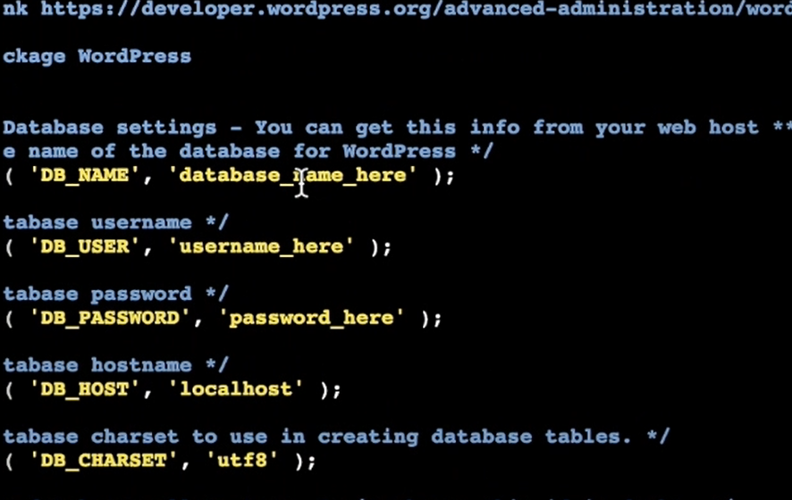

Step7: restart apache

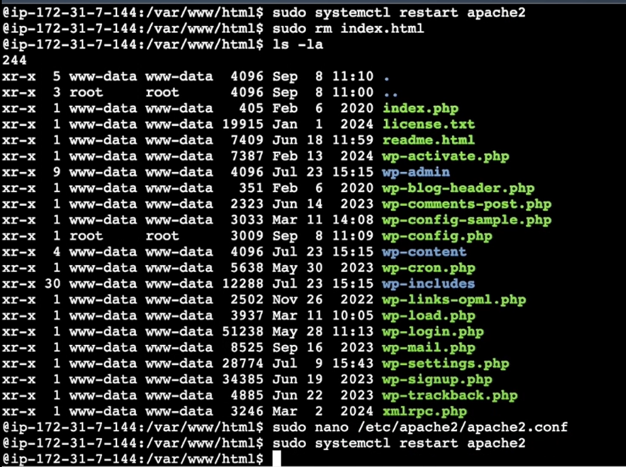

Step8: Setup wordpress

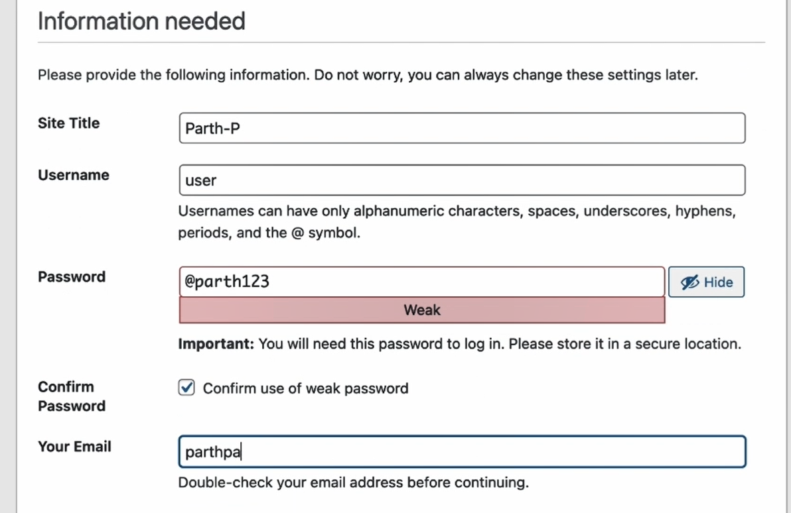

Step9: Login in wordpress

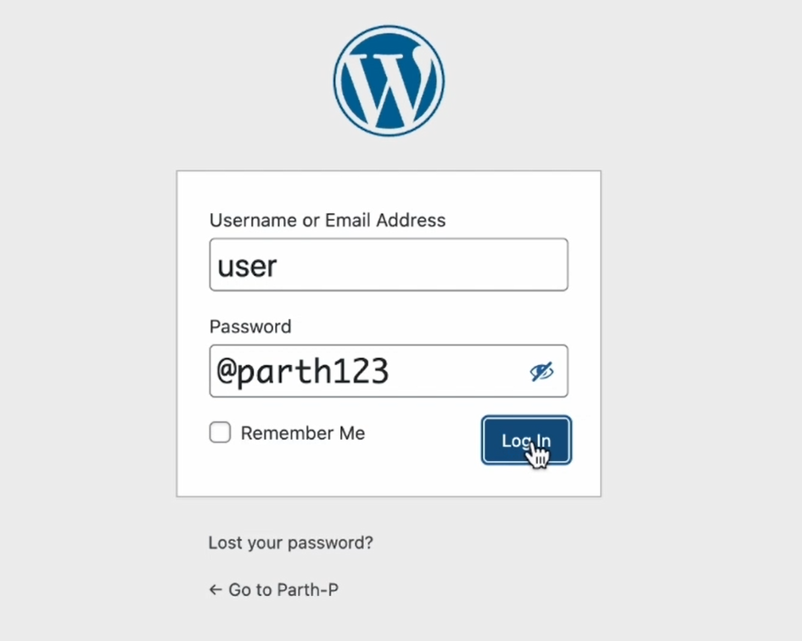

Step10: Create a sample page

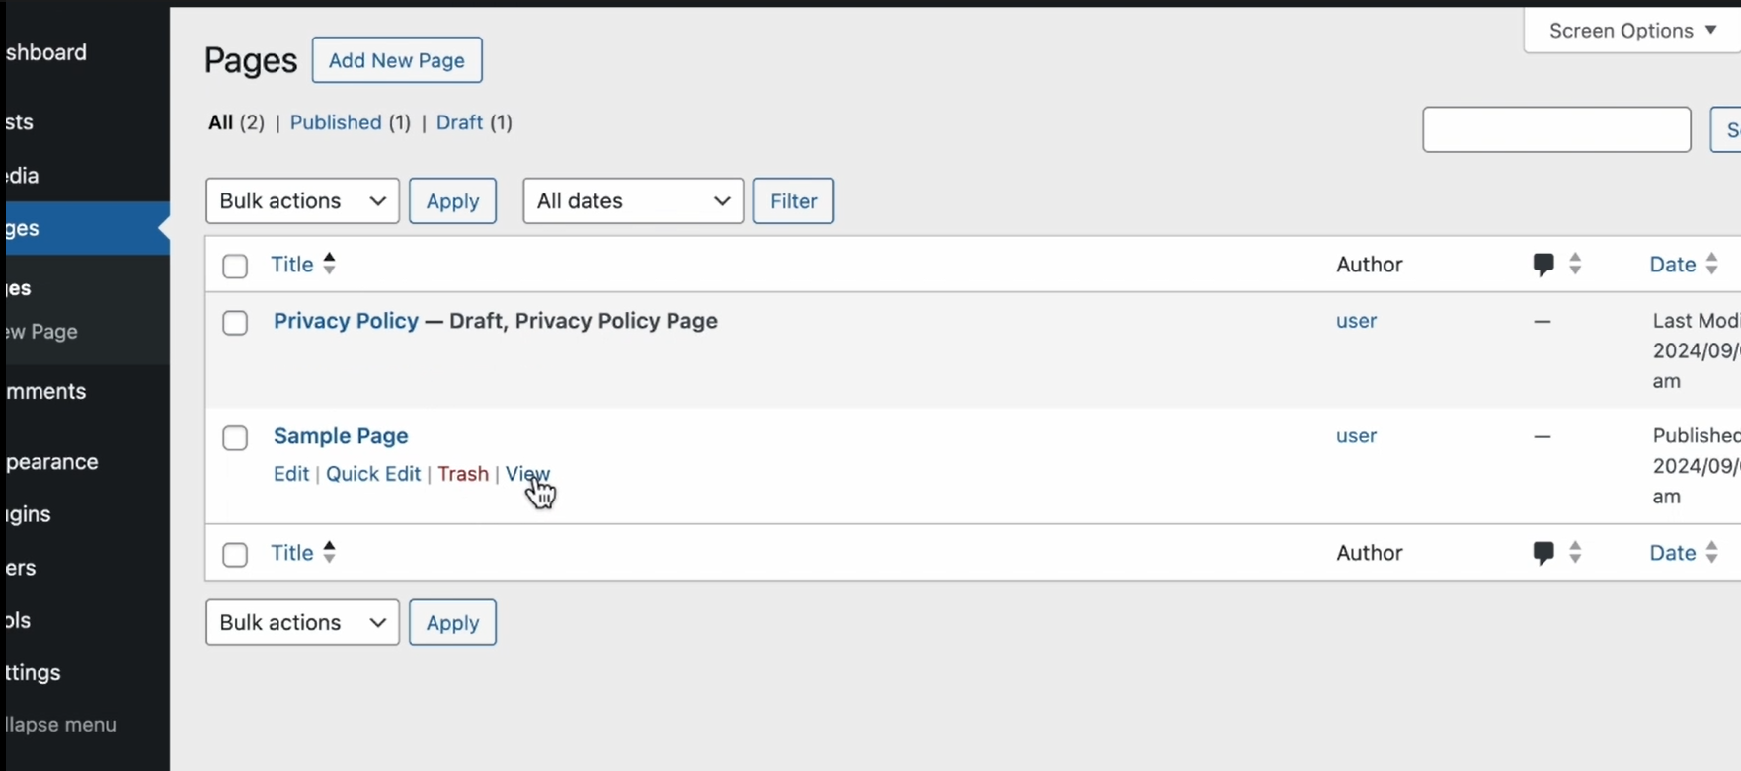

Step11: open sample page

